EMBEDUR NETWORKING ASSIGNMENT-3
MODULE-5

G ADITHYA PRASAD

Que 1: Capture and analyze ARP packets using Wireshark. Inspect ARP request and reply frames and discuss the role of the sender's IP and MAC address.
1.ARP request (ARP Who has 192.168.29.1? Tell 192.168.29.168)
2.ARP reply (192.168.29.1 is at 78:bb:c1:65:68:ea)

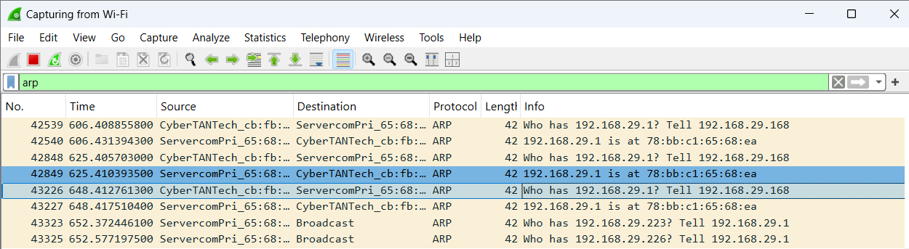

ARP REQUEST information:
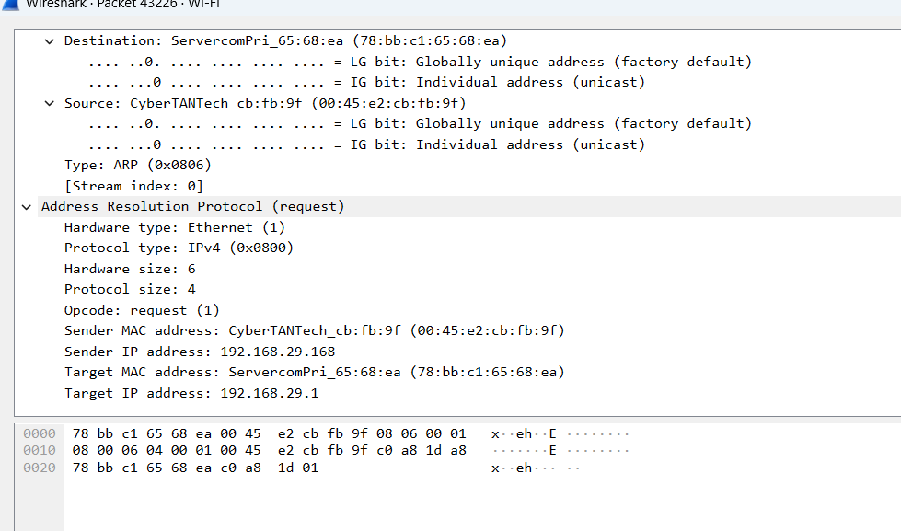
Inspecting ARP Reply:
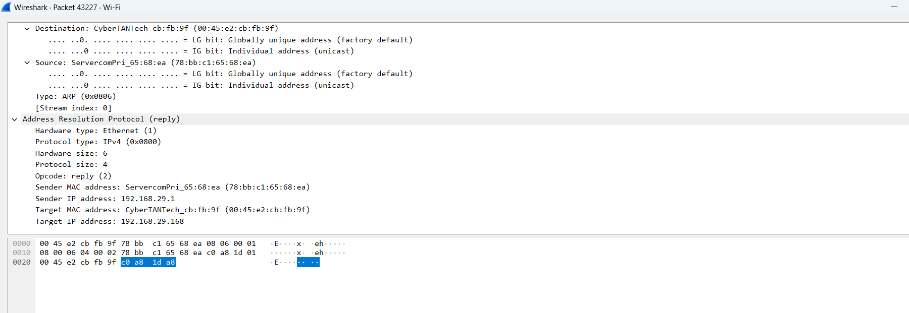

Que2: Using Packet Tracer, simulate an ARP spoofing attack and analyze the behavior of devices when they receive a malicious ARP response.

SOLUTION:
STEP 1:CREATE TOPLOGY
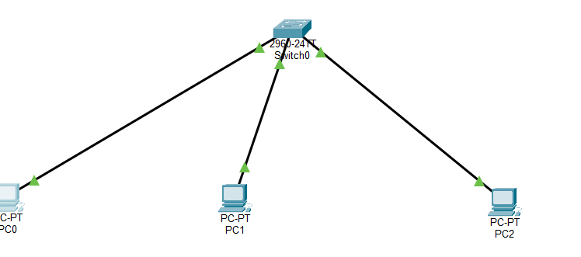
STEP 2:Verify Normal ARP
On PC0 → Command Prompt
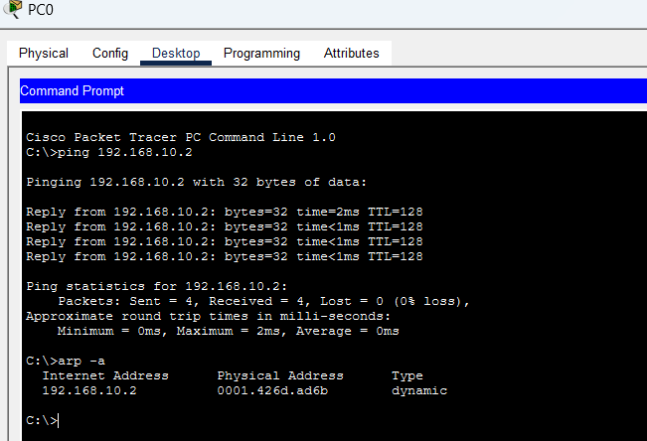
ping 192.168.1.20
arp -a
You should see:
192.168.1.20 → MAC of PC1

STEP 3:

Go to PC0 → Command Prompt:
ping 192.168.1.3
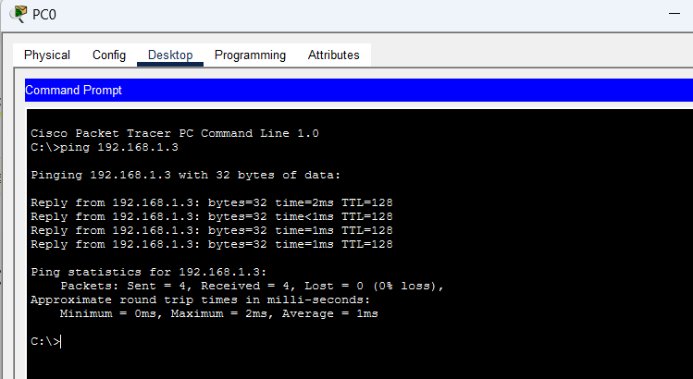
This shows the normal communication.
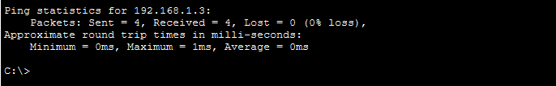

- When a device wants to communicate, it needs the MAC address of the destination.
Example: PC1 (192.168.1.2) wants to send data to PC2 (192.168.1.3)
- PC1 sends a broadcast ARP request:
“Who has 192.168.1.3?”
- The actual device (PC2) replies with its MAC address.
Example: “192.168.1.3 is at AA:BB:CC:11:22:33”
- PC1 stores this in its ARP table.
Example:
192.168.1.3 → AA:BB:CC:11:22:33

- In an ARP spoofing attack, an attacker sends a fake ARP reply.
Example: Attacker (192.168.1.100) sends:
“192.168.1.3 is at FA:KE:11:22:33:44”
- The victim device (PC1) does not verify the reply and accepts it.
- The ARP table gets updated with the wrong MAC address.
Example:
192.168.1.3 → FA:KE:11:22:33:44 (Attacker MAC )

- Now all traffic meant for PC2 is sent to the attacker instead.
Example flow:
PC1 → Attacker → PC2
- The attacker becomes a middleman (Man-in-the-Middle attack).

- The attacker can monitor and capture sensitive data.
Example: passwords, login details
- The attacker can modify the data before forwarding.
Example: changing message content
- The attacker can also drop packets.
Example: network stops working (Denial of Service)
- This attack works because ARP has no authentication mechanism.
Devices trust any ARP reply they receive

SOLUTION:
PC0 (Victim) | 192.168.10.1
PC1 (Attacker) | 192.168.10.2
PC2 (Other/Gateway) | 192.168.10.3

PC0> ping 192.168.10.2
PC0> arp -a
ARP is normal now

Step 1 — Get attacker MAC (PC1)
Go to: PC1 → Config → FastEthernet
Copy the MAC Address.
Example: 00D0.BC11.2222 (yours will be different)

Step 2 — Poison ARP on Victim (PC0)
Go to: PC0 → Desktop → Command Prompt
Type:
arp -s 192.168.10.3 <MAC_of_PC1>
Example:
arp -s 192.168.10.3 00D0.BC11.2222
Meaning:
“IP 192.168.10.3 belongs to attacker MAC”
This is the spoof.

Step 3 — Verify ARP table (Proof)
On PC0:
arp -a
You must now see:
IP | MAC
192.168.10.3 | MAC of PC1
Spoof successful.

Step 4 — Generate traffic
From PC0:
ping 192.168.10.3

Step 5 —
Switch to Simulation Mode.
You will observe:
- PC0 sends frames to PC1 MAC instead of PC2
- Attacker is in the path

3. Configure Static IPs and test connectivity between two PCs
Here we, Assign manual (static) IP addresses , Connect two PCs ,Check if they can communicate using ping.
Static IP means:
- You manually assign IP
- It does NOT change automatically
Network part = first 3 numbers
192.168.1.X
So:
- PC1 → 192.168.1.1
- PC2 → 192.168.1.2
Same network → they can communicate
Now doing the ping test in PC0,
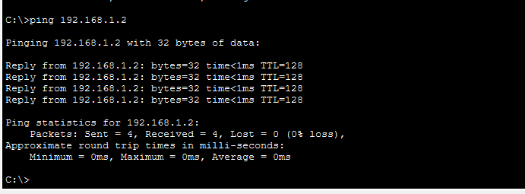
4. Use wireshark to capture DHCP DISCOVER,OFFER,REQUEST AND ACKNOWLEGE MESSGES AND EXPLAIN THE PROCESS.
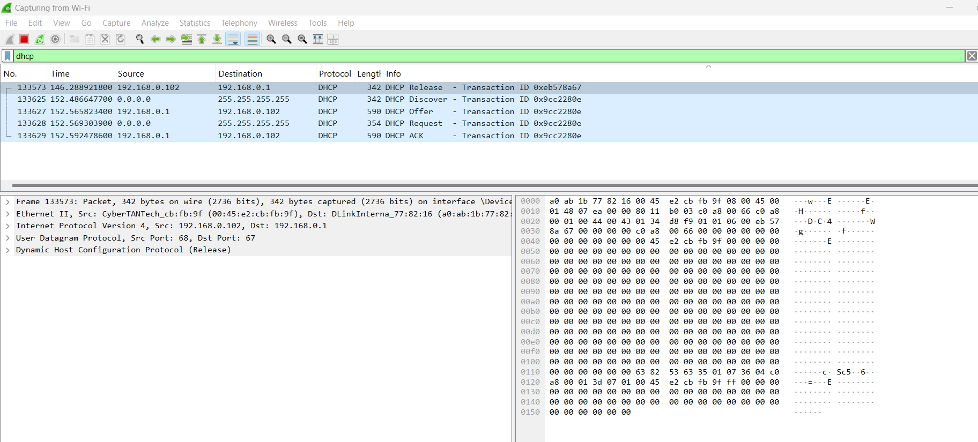

Que5: Given IP range 192.168.1.0/24, divide into 4 subnets and verify connectivity using cisco packet tracer.

Assign IPs to PCs

Subnet 1 (192.168.1.0/26)
- PC1 → 192.168.1.2
- PC2 → 192.168.1.3
- Gateway → 192.168.1.1

Subnet 2 (192.168.1.64/26)
- PC3 → 192.168.1.66
- PC4 → 192.168.1.67
- Gateway → 192.168.1.65

Subnet 3 (192.168.1.128/26)
- PC5 → 192.168.1.130
- PC6 → 192.168.1.131
- Gateway → 192.168.1.129

Subnet 4 (192.168.1.192/26)
- PC7 → 192.168.1.194
- PC8 → 192.168.1.195
- Gateway → 192.168.1.193
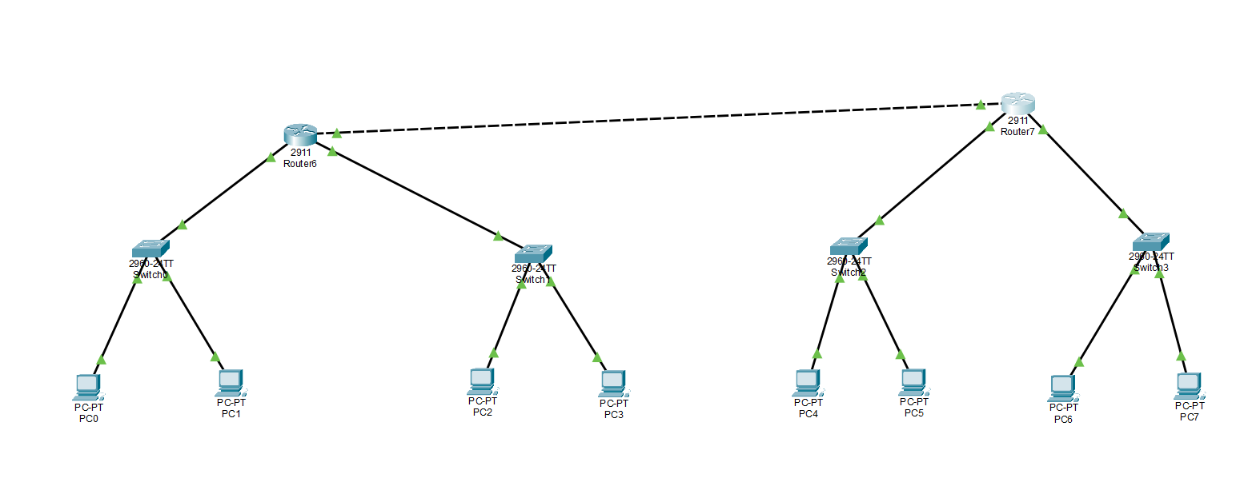

PCO config:

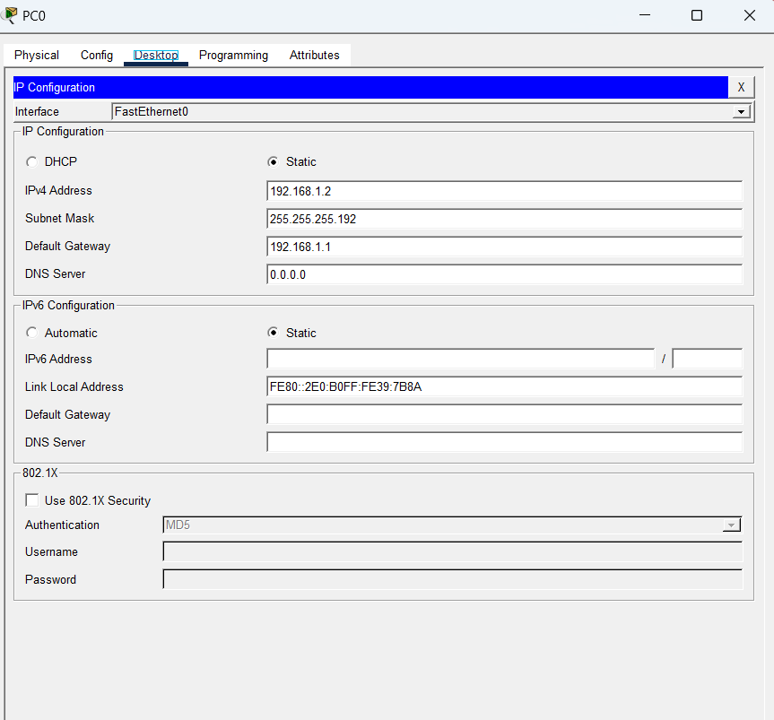
PC1 Config:

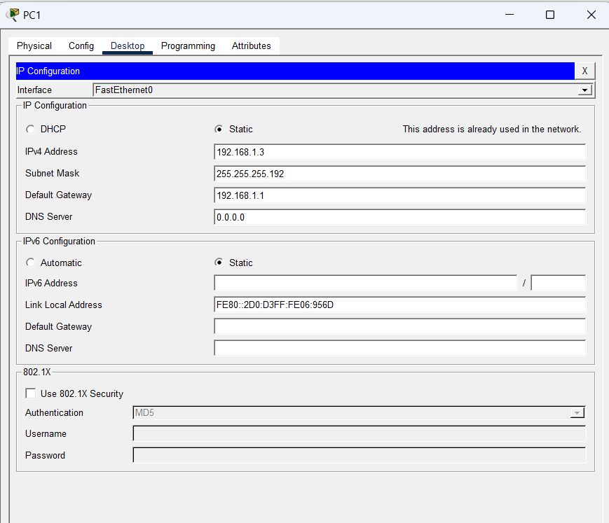

PC2 Config:
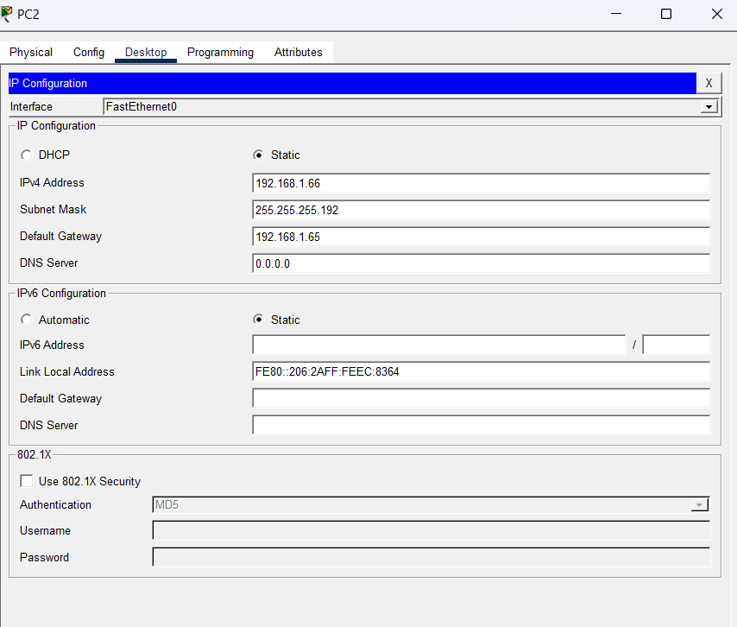
PC3 CONFIG:
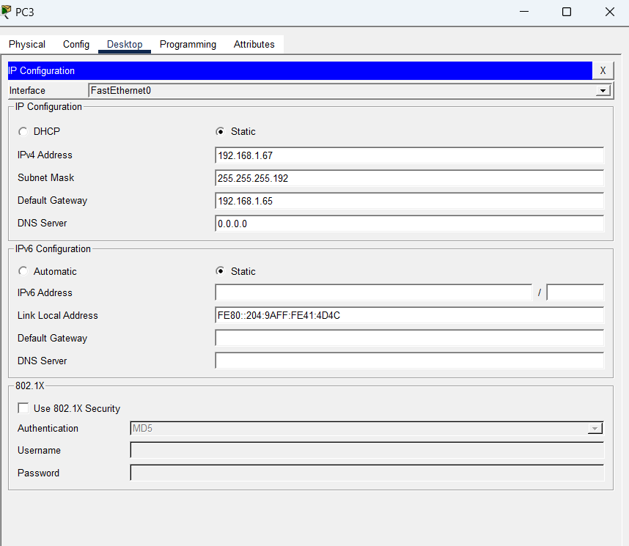

PC4 CONFIG:
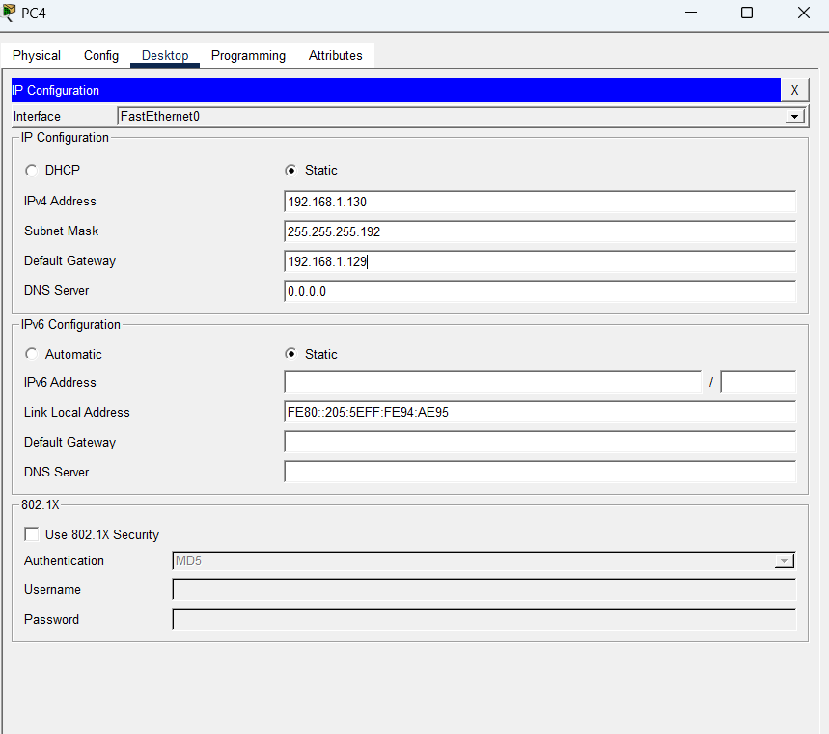
PC5 config:
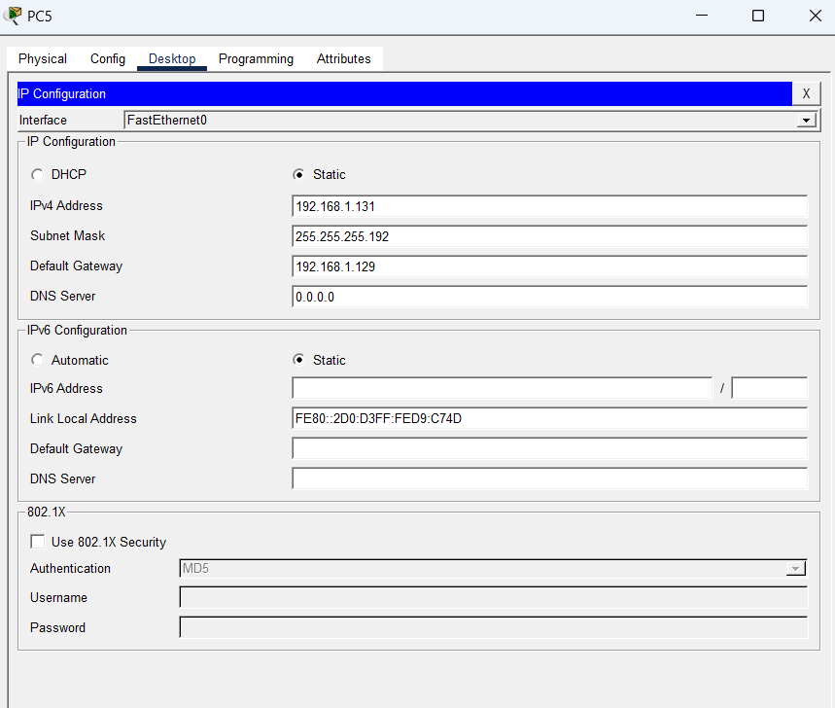
PC6 config:
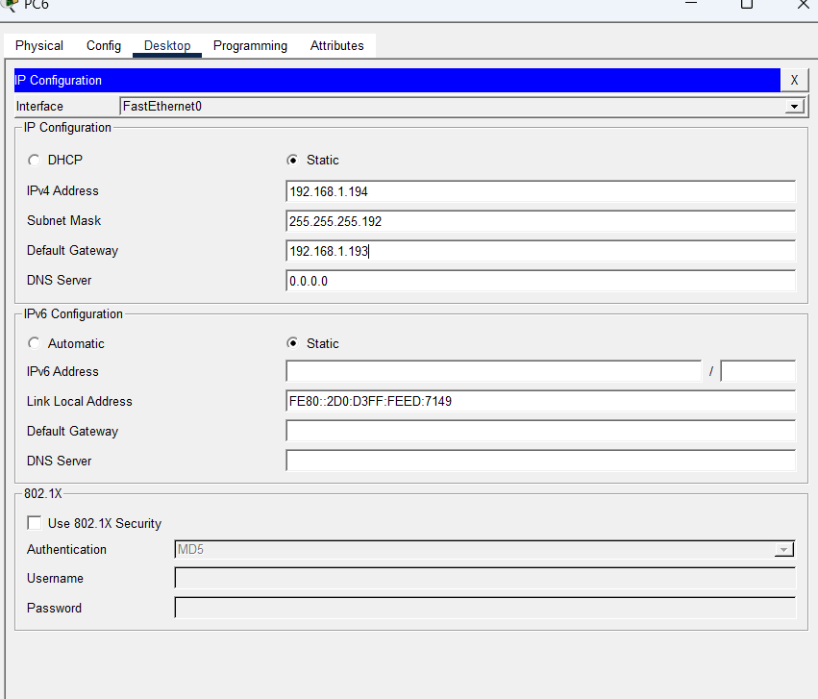

PC7 Config:
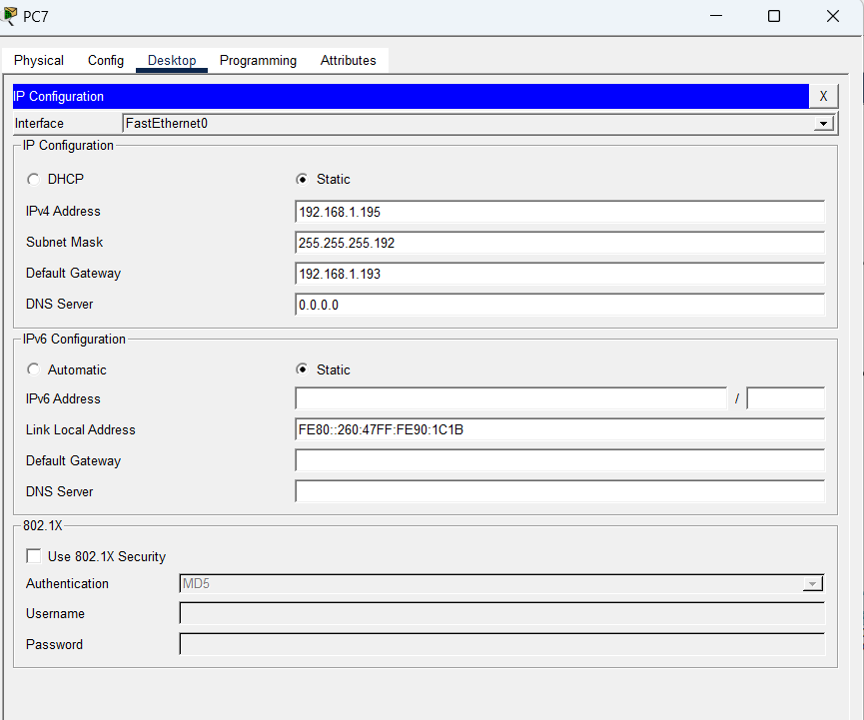

NOW CONFIGURING ROUTERS,
FOR ROUTER 1,
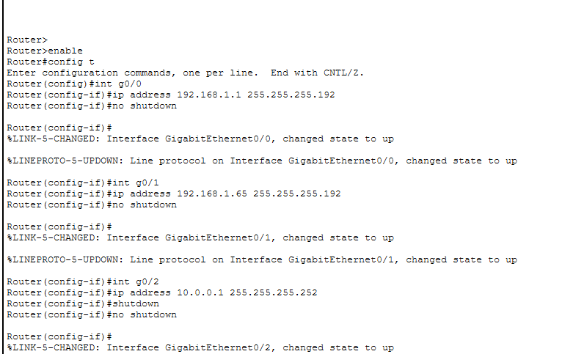

For router 2 config,
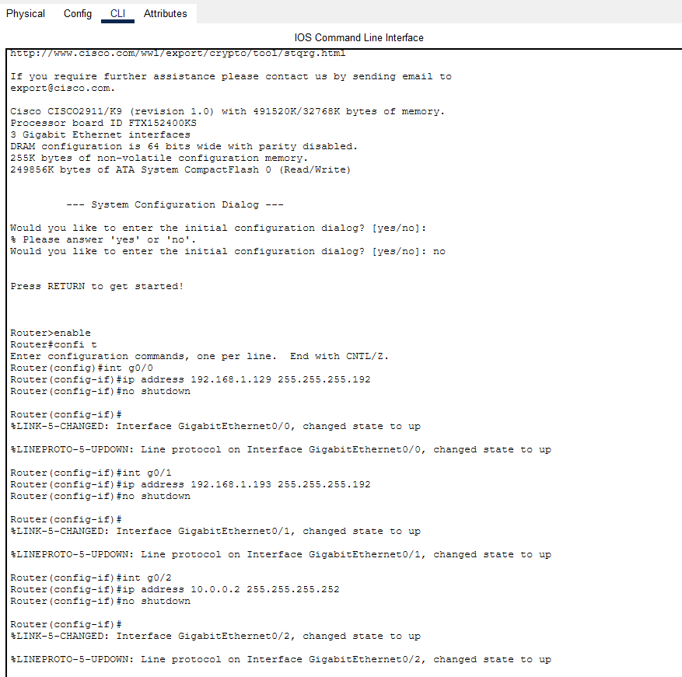

Now, ADDING STATIC ROUTES:
If we do this, it can get to the routes in other subnets as well.
For router-1,
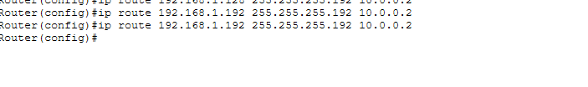
For router-2,

Finally checking network connectivity from any PC connected.
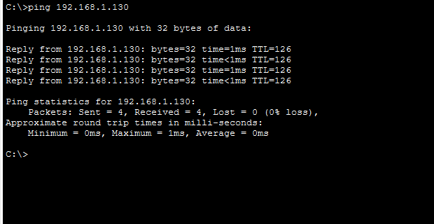

Que6: Given IP addresses: 10.1.1.1, 172.16.5.10, and 192.168.1.5
Step 1: Identify the class of each IP address
IP address classes are determined based on the first octet:
- Class A: 1 – 126
- Class B: 128 – 191
- Class C: 192 – 223
Applying this rule:
- 10.1.1.1
  - First octet = 10
  - Falls in range 1–126
  - Therefore, it is Class A
- 172.16.5.10
  - First octet = 172
  - Falls in range 128–191
  - Therefore, it is Class B
- 192.168.1.5
  - First octet = 192
  - Falls in range 192–223
  - Therefore, it is Class C

Step 2: Determine the default subnet mask for each class
Each IP class has a default subnet mask:
- Class A → 255.0.0.0
- Class B → 255.255.0.0
- Class C → 255.255.255.0
Applying this:
- 10.1.1.1 → 255.0.0.0
- 172.16.5.10 → 255.255.0.0
- 192.168.1.5 → 255.255.255.0

Step 3: Provide the range of IP addresses for each class
- Class A Range:
1.0.0.0 to 126.255.255.255
- Class B Range:
128.0.0.0 to 191.255.255.255
- Class C Range:
192.0.0.0 to 223.255.255.255

QUE7: In Cisco Packet Tracer, configure NAT on a router to allow internal devices (192.168.1.x) to access the Internet.
Test connectivity by pinging an external public IP.
Capture the traffic in Wireshark and analyze the source IP before and after NAT translation.
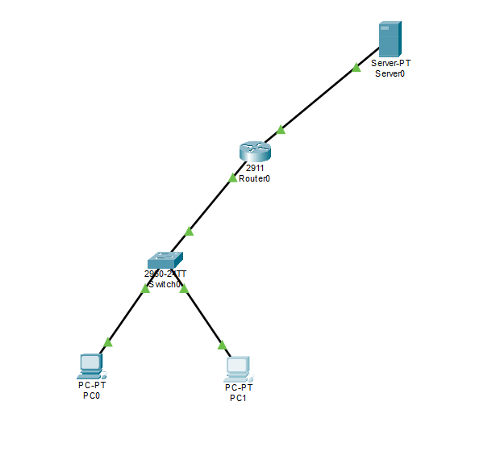
Step 1 — Create the Topology
Place devices
Drag:
- Router 2811
- Switch 2960
- PC0, PC1
- Server
Cabling (Copper Straight-Through)
From | To
PC0 Fa0 | Switch Fa0/1
PC1 Fa0 | Switch Fa0/2
Switch Fa0/24 | Router Fa0/0
Router Fa0/1 | Server Fa0

Step 2 — Assign IP to PCs
PC0
Desktop → IP Config
- IP: 192.168.1.10
- Mask: 255.255.255.0
- Gateway: 192.168.1.1
PC1
- IP: 192.168.1.11
- Mask: 255.255.255.0
- Gateway: 192.168.1.1

Step 3 — Configure Server (Internet)
On Server → Desktop → IP Config
- IP: 200.0.0.2
- Mask: 255.255.255.0
- Gateway: 200.0.0.1

Step 4 — Configure Router Interfaces
Open CLI on Cisco 2811
enable
configure terminal
interface fa0/0
ip address 192.168.1.1 255.255.255.0
no shutdown
ip nat inside
exit
interface fa0/1
ip address 200.0.0.1 255.255.255.0
no shutdown
ip nat outside
exit

Step 5 — Create ACL for Internal Network
access-list 1 permit 192.168.1.0 0.0.0.255

Step 6 — Configure NAT (PAT / Overload)
ip nat inside source list 1 interface fa0/1 overload
Both PCs will share 200.0.0.1.

Step 7 — Add Default Route
ip route 0.0.0.0 0.0.0.0 200.0.0.2

Step 8 — Test Connectivity
From PC0 and PC1 command prompt:
ping 200.0.0.2
Both should reply.

Step 9 — Verify NAT on Router
show ip nat translations

